**LUXURY ADVENTURE SAFARI**

## [www.kaonekasafaris.co.tz](http://www.kaonekasafaris.co.tz)

## HANDCRAFTED BY THE TRAVEL EXPERT AT

KAONEKA SAFARIS LIMITED

**SAFARI HIGHLIGHTS**

|  |  |  |  |
| --- | --- | --- | --- |
| **DAY** | **LOCATION** | **ACCOMMODATION** | **MEALS** |
| **1** | **ARRIVAL ARUSHA** | PRIVATE RESIDENT | **FB** |
| **2 - 3** | **ARUSHA CITY** | PRIVATE RESIDENT | **FB** |
| **4 - 5** | **ARUSHA CITY** | PRIVATE RESIDENT | **FB** |
| **6 – 7** | **TARANGIRE N. PARK** | MPINGO RIDGE | **INCLUSIVE** |
| **8 – 9** | **NGORONGORO HIGHLANDS** | GIBB’S FARM LODGE | **FB** |
| **10** | **CENTRAL SERENGETI N. PARK** | NANYUKI TENTED LODGE | **INCLUSIVE** |
| **11 – 12** | **NORTHERN SERENGETI N. PARK** | KURIA HILLS TENTED CAMP | **INCLUSIVE** |
| **13** | **RUHENGERI – VOLCANO N. PARK** | BISHOPS HOUSE | **INCLUSIVE** |
| **14** | **RUHENGERI – VOLCANO N. PARK** | BISHOPS HOUSE | **INCLUSIVE** |
| **15** | **KIGALI** | KIGALI SERENA HOTEL | **FB** |
| **16** | **KIGALI TO AIRPORT** | FLY BACK HOME | **L** |

**ITINERARY**

***Day 1, Arrive Kilimanjaro International airport from Amsterdam***

Up on arrive. Your private guide from Kaoneka Safaris will greet you and transfer to your luxurious accommodations. Private resident near Arusha airport with a good view of Meru and Kilimanjaro.

*Private Resident – Breakfast, lunch & dinner*

*.*

***Day 2, Arusha city – Culture heritage museum***

This day is a sleeping in day and wake up on time for breakfast. Drive to culture heritage centre for shopping and museum visit.

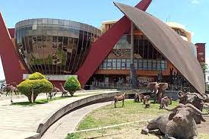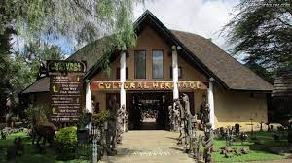

***Day 3-4, Arusha city – Kili Golf Club***

After breakfast drive to Kili golf club for your 19 halls play. Lunch at Kili golf club and after golfing drive back to your accommodation.

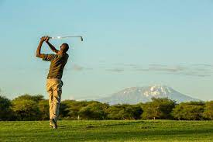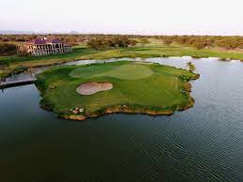

***Day 5, Arusha to TarangireNational Park***

After having breakfast at your private home, you will depart the bustling city of Arusha and head to Tarangire National Park for game drive. Arrival Mpingo Ridge for hot lunch. Before your journey begins, your guide will brief you and review expectations for your safari, giving you a taste of what is to come. Please feel free to ask your guide questions and also as they come up during your safari. Overnight at Mpingo Ridge.

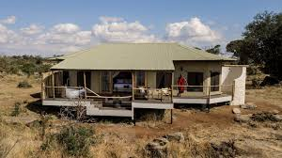 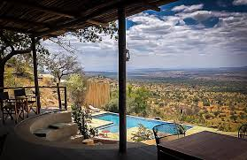

*Mpingo Ridge, all inclusive - breakfast, lunch, dinner and beverages - water, tea, coffee, soft drinks and house wine.*

***Day 6, Full day game drive in Tarangire National Park***

Full day game drive in Tarangire National Park. Continue exploring Tarangire, taking in the diverse wildlife and landscape. Watch for Guinea Fowl alongside your vehicle and leopards that sometimes lurk in the grasses near the road. You never can tell what is just around the corner…. Enjoy another packed lunch, dining in the picnic grounds within the park. Afterward, you are off to explore the park during the afternoon as temperatures cool and the big cats wake from their midday naps. Overnight at Mpingo Ridge for another delightful evening.

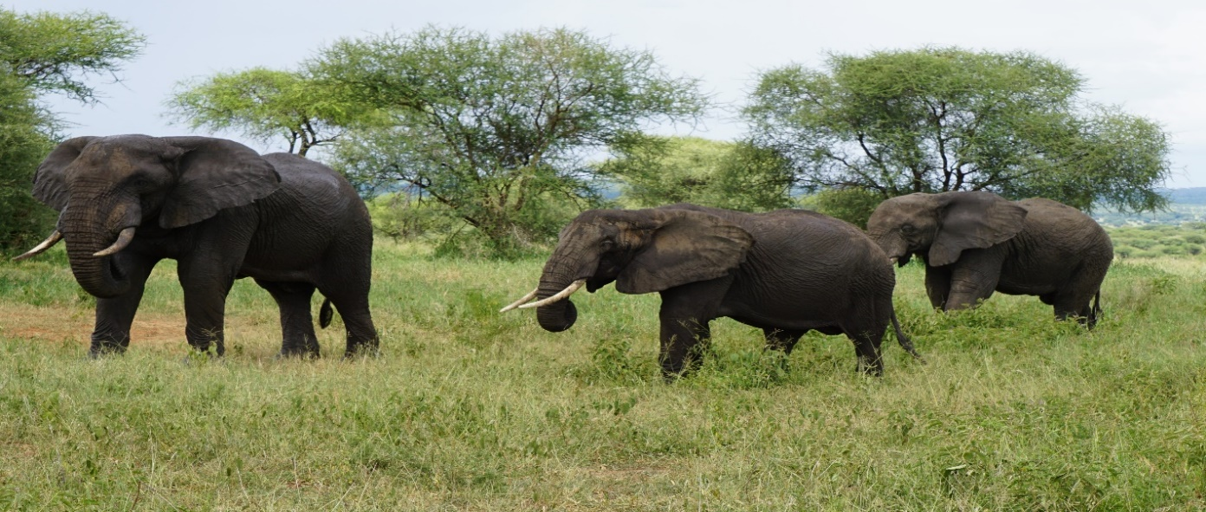

***Day 7, Tarangire to Ngorongoro Highlands***

After breakfast at Mpingo you will make your way to the Ngorongoro Highlands enjoying a scenic road trip while taking in all the magical landscapes of Tanzania en route. Visit the local people at Mto wa Mbu and see their daily activities. After one and half or two hours of walking on the cultural tour at Mto wa Mbu you will drive up on the cliff of Great Rift Valley and stop at Manyara Serena for lunch then proceed to Ngorongoro Highlands. Overnight at Gibb’s Farm Lodge.

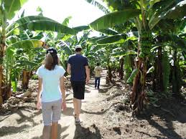 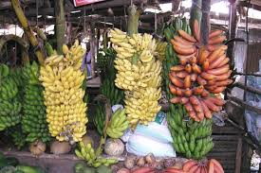

***Day 8, Full day game drive in Ngorongoro Crater***

Breakfast then off you go with a packed lunch to make your way to the Ngorongoro Crater. You will descend into the crater some 600 meters to experience the true spirit of Africa, home of wildlife population, long regarded as Africa’s “Garden of Eden”. Enjoy a full day to explore within the Crater, home to the black rhino almost on the brink of extinction as well as lions, hyenas, zebras and gazelles. Then back to the Lodge for relaxation and a delightful dinner.

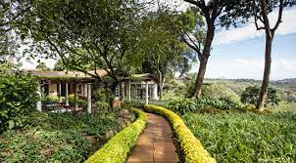 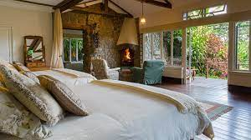

*Gibb’s Farm Lodge – Full-board, Breakfast, Lunch, Dinner*

***Day 9, Ngorongoro to Central Serengeti***

Breakfast and packed lunch as you make your way to the Central Serengeti. visit at archaeologically rich Olduvai Gorge en route and then visit a Maasai village and meet with an elder to learn about local culture and traditions. Witness a traditional beadwork demonstration as part of an artisan visit. Take in all the colors and sights as you head out for another amazing adventure. Explore the savanna and have your cameras ready since it is never a dull moment of what you might see in the Serengeti. Overnight accommodations Serengeti Four Seasons Lodge

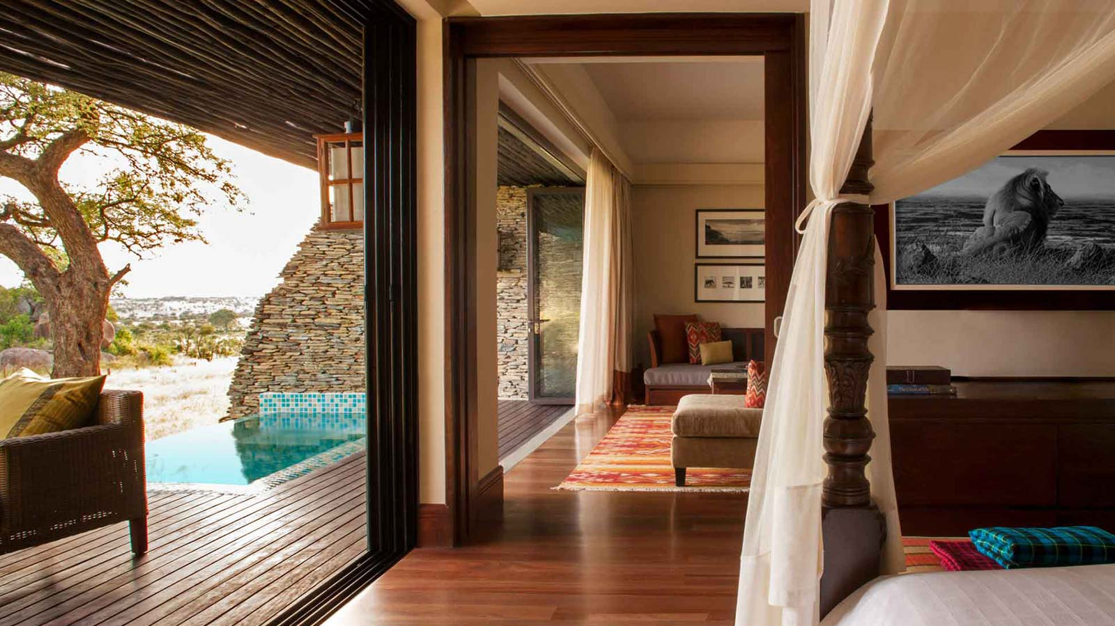

*Serengeti Four Seasons Lodge, All inclusive- breakfast, lunch, dinner and beverages - water, tea, coffee, soft drinks and house wine.*

***Day 9, Full game drive Central Serengeti***

After a good night’s rest, enjoy a delightful breakfast where you may talk of hearing lions roar during the night before staking their turf or sounds of hyenas making their way through lodge in search of food. Head out for another day of adventure with a packed lunch. The Serengeti is renowned for the great migration and crossing of the river that takes place late summer, early fall but it is often misunderstood that the migration is actually a year-round process involving millions of wildebeest and 200,000 zebras.

*Serengeti Four Seasons, All inclusive- breakfast, lunch, dinner and beverages - water, tea, coffee, soft drinks and house wine.*

***Day 10, Central Serengeti to Northern Serengeti***

After having breakfast at the Mount Four Seasons Lodge, you will depart the Central Serengeti and head to Northern Serengeti game drive on the way. Arrival Kuria Hills for hot lunch

**

*Kuria Hills Tented Camp, All inclusive- breakfast, lunch, dinner and beverages - water, tea, coffee, soft drinks and house wine.*

***Day 11-12, Northern Serengeti (Mara River)***

These two days after breakfast you will leave camp with lunch bascket for your full day’s drive. You will be looking for Lions on the rocks (Kopjes), Leopards on the trees and concentrate more on Wildebeest and Zebra migration crossing, Crocodile and Hippos at the Mara River. Stop for leg stretch and lunch then proceed with game viewing. Late afternoon returns back to Camp.

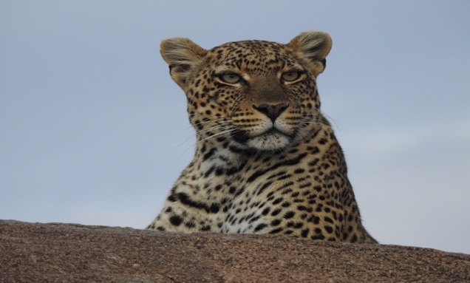

*Kuria Hills Tented Camp, All inclusive- breakfast, lunch, dinner and beverages - water, tea, coffee, soft drinks and house wine.*

***Day 13, Serengeti National Park fly to Kigali***

After breakfast you will drive to Koga Kuria airstrip and say goodbye Tanzania. Depart for Kigali with a private charter, 45 minutes flight to Mwanza and stop to clear immigration. This will take about twenty minutes or more, then from there another 1hour flight to Kigali International airport. You will be flying over Lake Victoria into Kigali Rwanda, the Land of a Thousand Hills and Parc des Volcans. You will be met by your Primate Safaris Guide and transferred for your overnight stay at Bishops house.

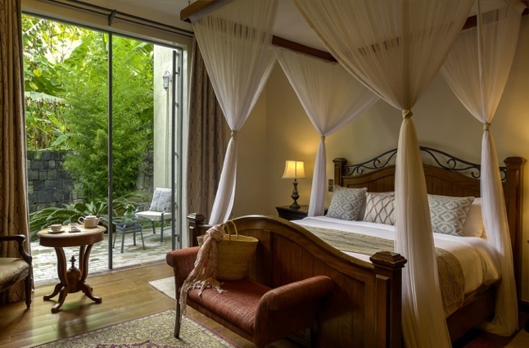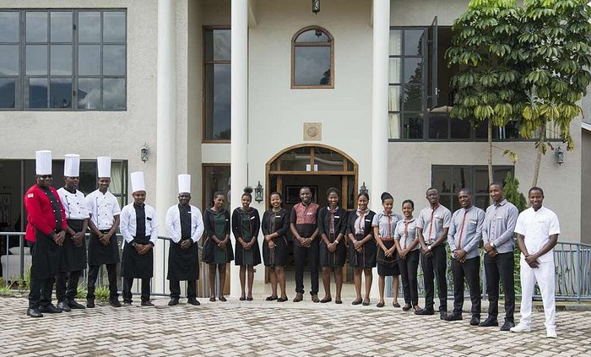

*Bishop’s house – Full-board, Breakfast, Lunch, Dinner*

***Day 14, Gorilla trekking Volcano National Park***

This day you will have an early morning wakeup and have breakfast at the hotel, then depart to Volcanoes National park Headquarters. Here you will be allocated to a group with a park ranger for your gorilla trek. The trekking can take several hours, climb to altitudes excess of

7500 feet. Your guide will go through an orientation on gorilla etiquette before you start. You will return to the lodge for lunch and shower then relax. Overnight stay at Bishops house

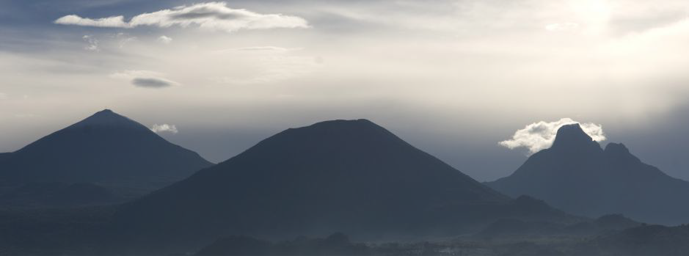 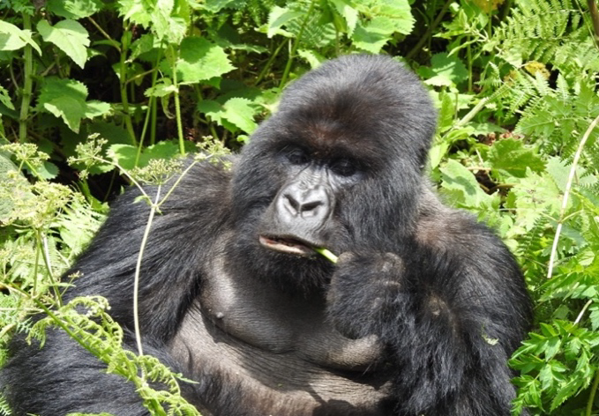

***Day 15, Bishop’s to Kigali Serena Hotel***

This day after breakfast you will drive to Kigali City, hot lunch at Serena Hotel then relax and overnight stay.

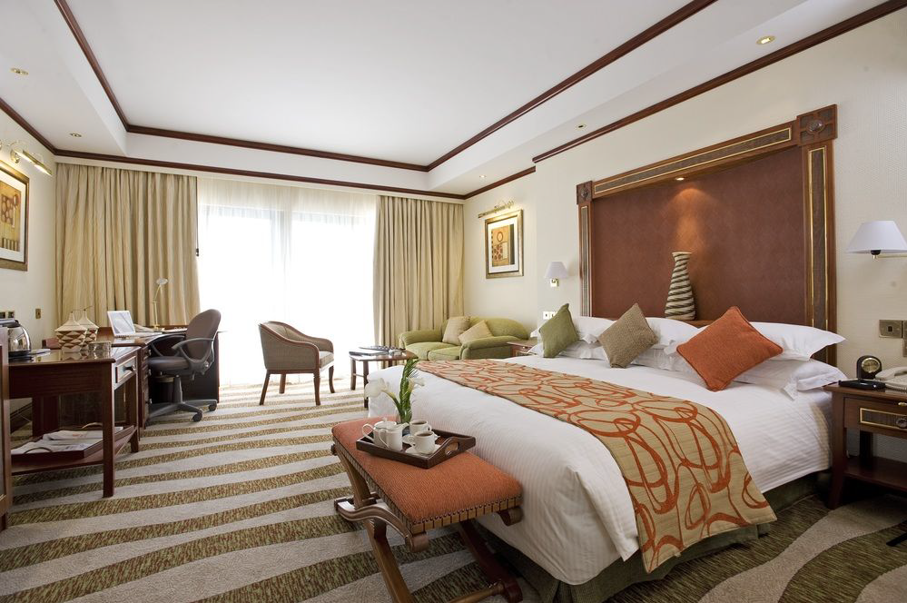 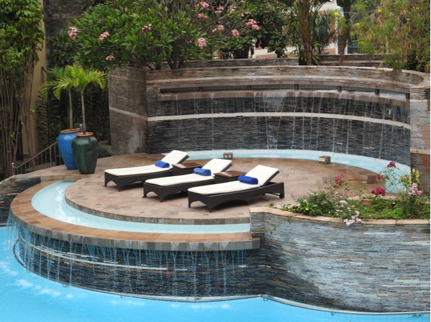

*Kigali Serena Hotel – Full-board, Breakfast, Lunch, Dinner*

***Day 16, Bishop’s Kigali Genocide Museum tour – Night fly back home***

This day after breakfast you will be picked up and drive to the Genocide Museum and City tour for two or three hours visit, then go for lunch at Serena Hotel. Day room use and final packing at Kigali Serena Lodge. You will be transferred to Kigali International Airport for check in and departure back home***.***

**~ END OF SAFARI ~**

**WELCOME TO EAST AFRICA – TANZANIA AND RWANDA**